**2. Day Trading Essentials**

**Risk & Account Management**

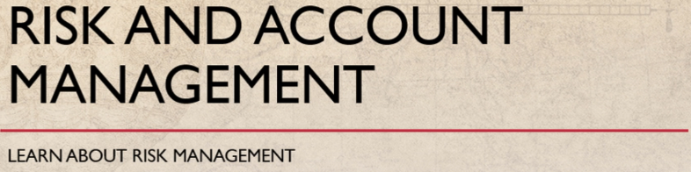

Risk : Reward ratio = 1 : 2

100 rs trade = 10 : 20

It is much safer to adopt our trading strategy that will allow your account to grow at a slower pace over time day trading is one of the fastest ways to grow a small account when it is done properly but most people do not trade properly.

Successful day trader can make a 200 percent in return per year the strategies suggested in the course have positive expectancy.

If executed properly and to be a successful trader

not only you must learn strategies but also learn about the risk management find low risk entries with a high potential reward the minimum risk reward ratio is what is 1:2.

it means if you buy $100 worth of stock and are risking $10 on it you must sell it for at least $120.

But if price comes down to $90 you must accept the loss of $10 and exit that trade quickly using 1:2 risk reward ratio.

You can make money even if you are wrong 40 percent of the time as a day trader your job is not the buying and selling stocks but to manage your risk and your account.

but how do you manage that there are a few steps in managing risk and account with the first step always choose the right stock

**Risk management starts from choosing the right stock.**

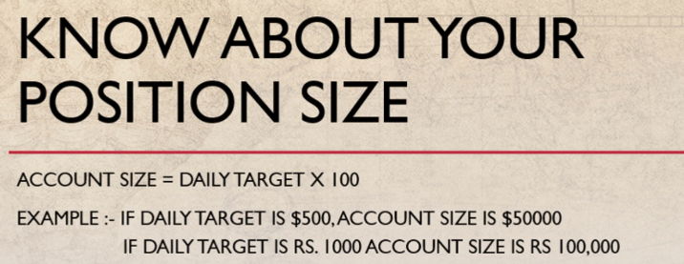

You can be a master of strategies.

But if you are trading the wrong stock you will definitely lose money how to choose the right stock for day trading we will discuss in the next lecture.

The second step is know about your position size.

How much share you want to trade is depends on your account size and how much money do you need to get started depends on your daily target.

For this multiply your daily target by 100 and that should be your trading account for day trading

Suppose your daily target is $500 then your trading account should have $50000.

Or if your daily target is thousand rupees than you should have a minimum of lakh rupees in your trading account

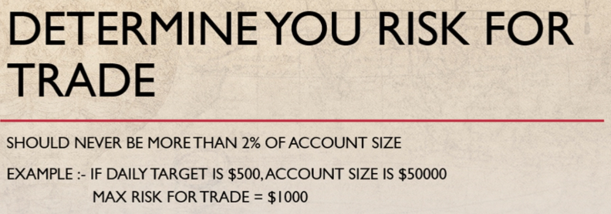

the third step for risk management is to determine your own risk trade and calculate this before your dating days starts.

You should never risk more than 2 percent of your account on any given trade.

If your trading account have $50000 you should never put more than 2 percent at risk means $1000 dollar.

If your trading account have one lakh rupees you should never put more than 2000 rupees on a trade.

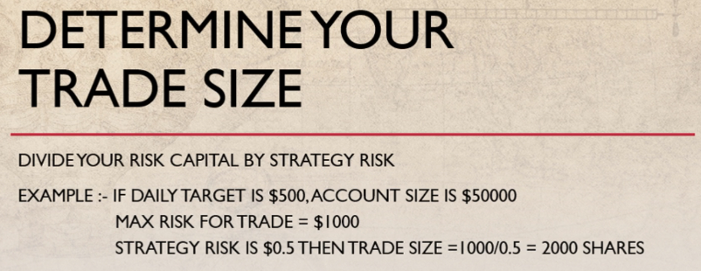

The next step is estimate your maximum risk per share means

**The strategy stop loss**

Find out the maximum number of shares that you should trend each time for this divided your risk capital by strategy risk.

For example if you have $50000 in your trading account your total risk capital is $1000 and

If your strategy risk is $.5 divide 1000 with 0.5 means you can create 2000 shares

or if your trading account have one lakh rupees your risk capital will be 2000 rupees and

Suppose your strategy risk is one rupee then you can trade 2000 shares.

It can be possible that you may not have enough cash in your account to buy 2000

shares if stock price is more than 50 rupees as you have one lakh rupees in your trading account

then you can buy a less number of shares because you gonna always risk less but shouldn't take risk more than two percent

of your trading account.

This all you will need to do false else you will lose the opportunity.

and it needs practice.

So I always recommend to paper trade for at least two months in a live simulated account.

Your maximum number of trade shouldn't be more than 10

And your risk capital shouldn't be more than 2 percent of your trading account on per trade

Day trading requires you to make quick decision and discipline approach if you follow the risk management rules and

manage your position size then you can be a success day trader.

It is not a strategy that makes you successful.

What it is a knowledge of strategy discipline.

to follow the rules and risk management that make you a successful day trader.

**How to Choose the Right Stock**

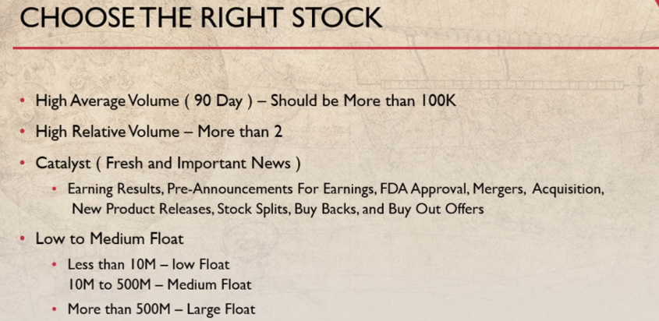

But if your stock do not move during the day then you cannot make money.

In day trading We don't want stocks to just more.

But we want those stocks that are about to move in a certain direction for day trading there are only a small handful of stocks easy to trade.

And here is a list of requirements for what makes a stock the right

trade to trade first of all we should note that how much volume is enough for a stock

We need our liquidity in the stock to be able to get in and out of the stock without difficulty because

if average volume is low you cannot exit quickly at your price.

So always trade the stocks that have an average volume of more than 100000 shares. In trading doesn't work on all stocks.

It works only on the stocks that have high relative volume.

Don't just look for high total volume

There are some stocks that on average trade with much volume but in day trading we need to look for above average volume for specific stock.

Stocks trade on heavy volume because they have a high level of retail interest and this interest is typically driven by news. Above average volume means that thousands of other traders are watching the same chart

and a breakout to the upside means that thousands of traders are buying up shares.

So we are one of those buys

if we trade that stock

The easiest way to see the above average volume for a stock is to use a stock screener and screen for high relative volume.

The relative volume for the day is translated into a number. one is average two is 2 times the average and so on In day trading we should choose stocks having above 2 times the relative volume

And so on After choosing the stock that have high relative volume

review each of those stocks to see if there is a catalyst for the stock

Usually it is a fundamental news about the stock either that day before or during the same trading day an important news or event for companies can have significant impact on their value and act as a fundamental

catalyst.

It can be earning results, pre-announcements for earnings, FDA approval, mergers, acquisition, new product releases,

stocks splits, buy backs, buy out offers, patent approvals etc..

When we are reviewing the news for a stall it is important to think about the quality of the source.

News release directly from the company, majority shareholders,

top tier analyst or government agencies will be the trustable news.

All stocks have a float

The float is the number of outstanding shares available to trade in the open market.

The float simply means supply. Day trader should be aware of float

Size of the stock they trade

By knowing the float of the stock we can recognize the potential of a stock. A stock

that have a low float will have less supply and then there is a good catalyst there will be a high demand for the stock and this can cause a big intraday move.

As a day trader we want a stock to be volatile

So we should trade the low float and medium float stocks. A less than 10 million float is a low float And 10 to 500 million is the medium float more than 500 million is a large float for the stock.

**For trading momentum strategies**

**we should choose only low and medium float stocks and for other strategies we can trade any float.**

So in this way you can choose the right stock for our day trade Trading the right stock and help to reduce our risk. As a day trader

We only interested in the highly active stocks each day The market is constantly changing and every day there

will be a new stock trading on heavy volume due to a catalyst In bullish as well as in the bearish market

there will always be volatility in the market and will give an opportunity to trade for day trading.

**How to Scale Out Your Trade**

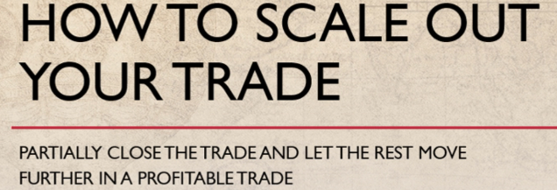

Welcome back in this lecture we will learn how to scale out in day trading In day trading by scaled out our

position we can enhance our gains and reduce our risk Scaling out is a strategy in which rather than letting

a target hit

and close out the entire position we instead partially close the trade and let the rest have the opportunity to

move further in a profitable trade. It means we set our targets at 1:1.5 risk to our ratio initially

And when we get a 1:1 risk reward we move our stop loss to break even level and move

Our target from 1.5 to 1:2 risk reward ratio.

When we get 1:1.5

We sell out half position. In this way

the remaining half position that is open is risk free and let the profits run with this position.

Let's take an example to understand this.

Suppose a stock is trading at 150 and we bought 1000 shares at 150 level. Our stop loss level is 49 and with a strategy of Stop-Loss is at 49 level.

So we set a stop loss at 149 and our first target level will be 151.5 level When stock reaches at 151 level

we shift our Stop-Loss from 149 to 150 level

that is the break even point and also shift our target from 151.5 to 152 level. When stock reaches the

151.5 we will immediately sell our half position means we will sell 500 shares and shifts our stop loss from 150 to 151 level.

If stock reaches to 153 level we will sell half of the rest position and shift stop loss to 152.

Now our stop loss has shifted to 150 level from 149 and we have only 250 shares left with us.

In this way we can minimize the risk and maximize our target profit by adopting this step by step approach.

**How to Scan the Stocks**

**Find Latest news**

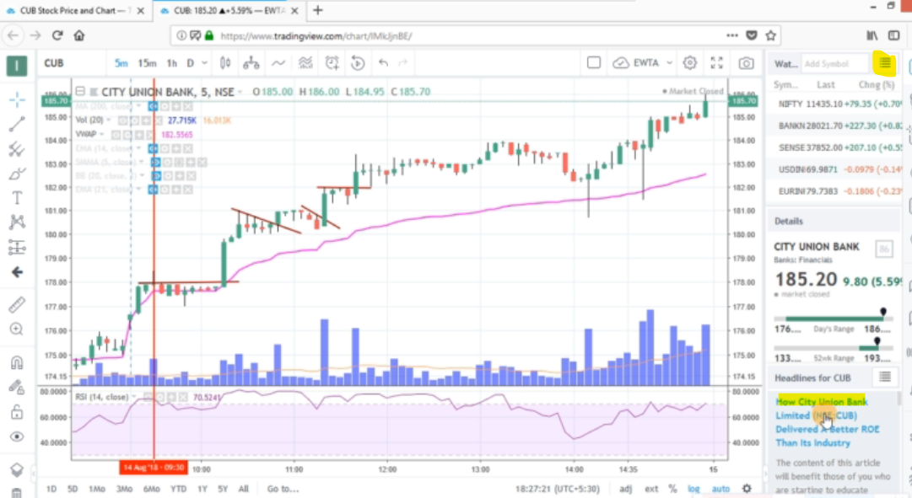

Use stock scanners to find high volume

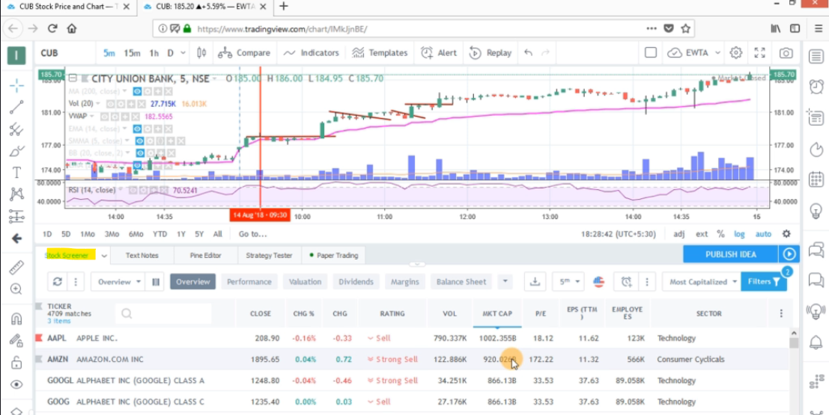

Filter below colums for this strategy

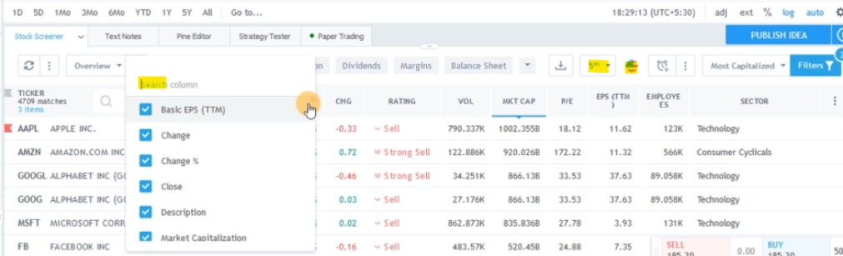

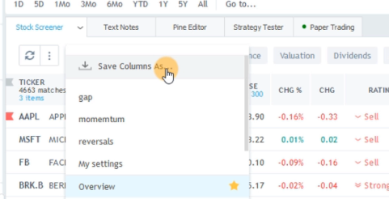

Momentum strategy columns:

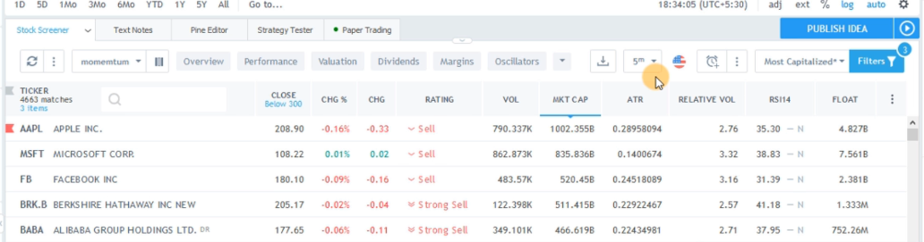

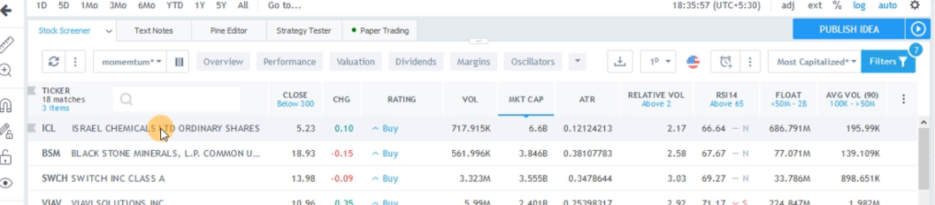

Now this is my momentum scanner for trading momentum strategies.

After the opening of market we can set the time frame as daily chart relative volume greater than 2 float should be low to medium average volume is greater than hundred k

now see there are 18 matches of stocks that have all these specification.

Rreversal strategy columns:

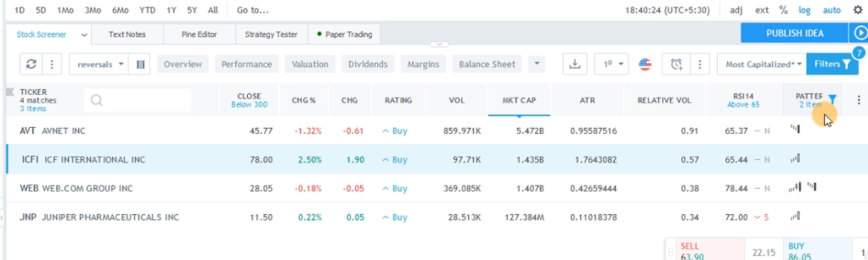

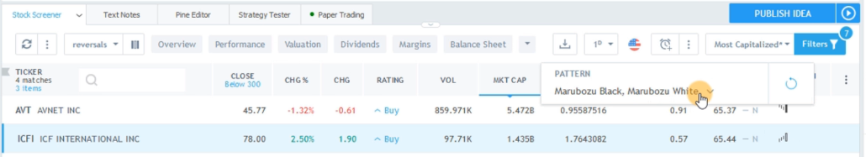

For reversal I just added one more column and that is the pattern column in which I'm filtering the candles for marubozu black and marubozu white it means for reversal strategies we always want the high of the day

or the low of the day.

These are the four stocks that are matching these specification the time interval is one day.

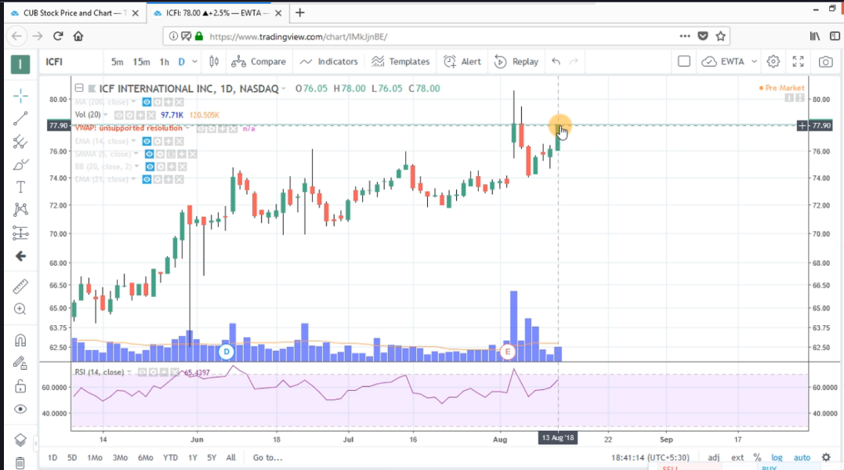

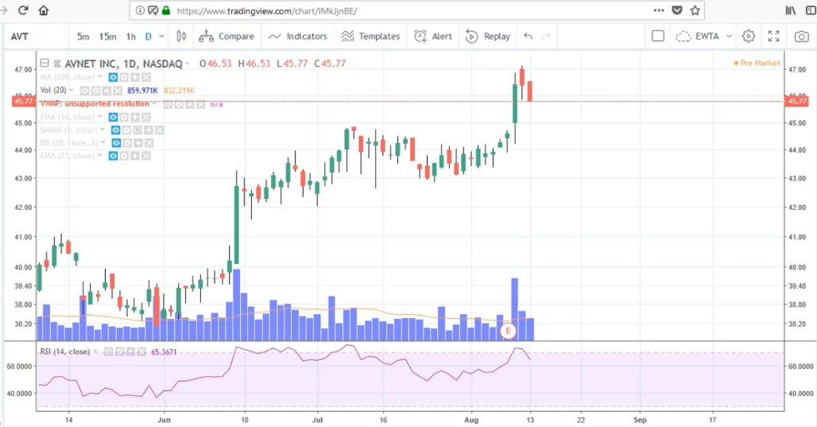

These are the four stocks that are matching these specification the time interval is one day.

See this is the daily candle.

The stock has closed at the high of the day.

This is the white or green marubozu candle.

And if we click on this stock we can see that this is the red or the black marubozu candle the stock has closed at the low of the day.

Now these are the specification after the closing of the market so we get the low of the day and the high of the day but we can scan the stock in between the session.

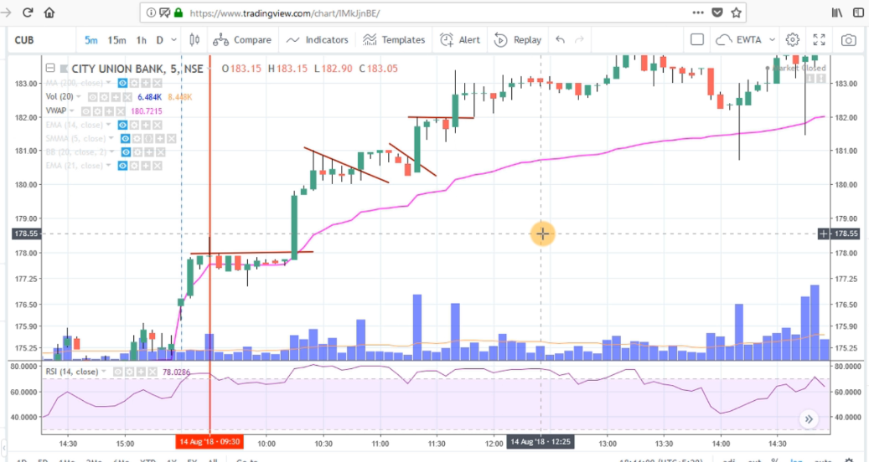

If we want to trade reversal now see this is the city union bank stock and after opening the market and

see after getting this signal.

This was the flat top break out then.

This was the bull flag again bull flag.

This is flattop and stock made a 6 percent move in a day.

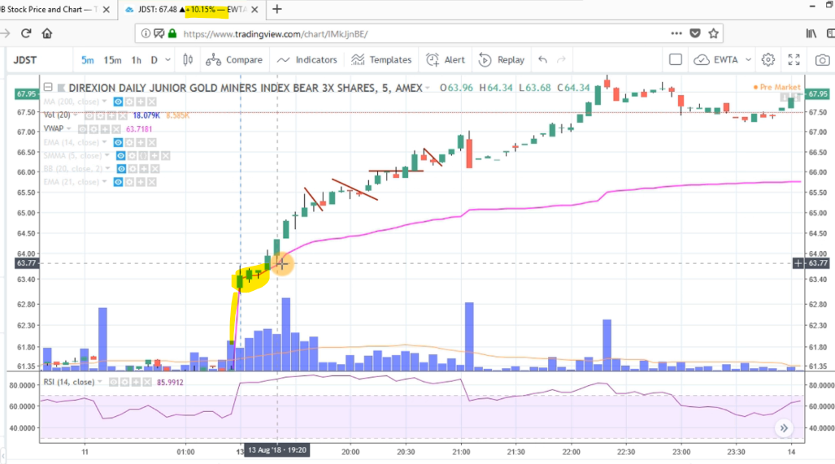

Now here is one more stock

This was the gap up opening of the stock and after opening the stock these three candles were consolidating

at VWAP

So this is a high momentum trade

And see this was bull Flag bull flag.

Then this is flat top.

break out.

Then again bull Flag stock made a 10 percent move in a day.

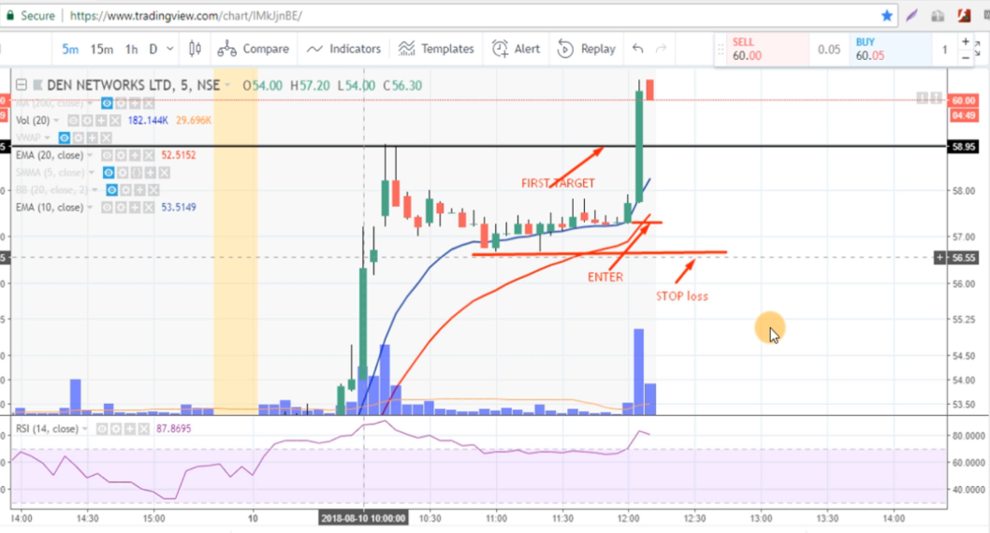

**How to Scan the Stocks Cont...**

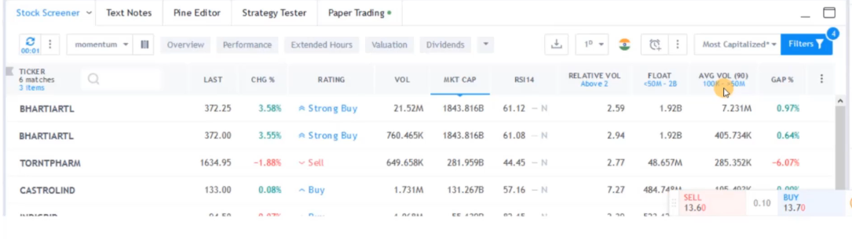

In the previous lecture we have learned how to scan the stocks for day trading but often I get queries

from my students that after market opens in this scanner they are not getting more than two or three

stocks though we should scan the stocks for relative volume greater than 2 low to medium flawed. Average

volume greater than 100k but if we don't get stocks with these parameters then we can scan the

stocks with changed parameter

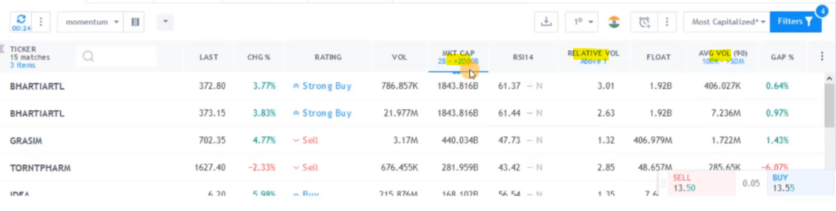So for day trading our scanner setting should be relative volume greater than two low to medium float average

volume greater than 100k or if we don't get any stock in the previous setting we can change our settings

in which relative volume should be greater than one average volume should be greater than 100k

and market cap should be greater than 2 billion.

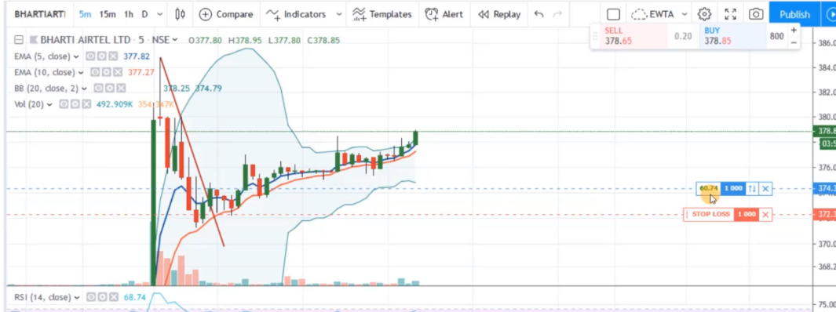

Now from these stocks today I traded few stocks we will analyze the trades see BHARTIARTL was present in the

scanner and you can see there was the high volatility in the prices.

The first candle was very long candle and then it was a shooting star candle after this candle

There was a selling signal in the stock so when this down move was complete.

I entered in my long position after getting Bull flag pattern the pattern we will study in later section

in momentum strategies

But here just see that in these stocks we can see a huge volatility in the prices and here I'm getting sixty

dollar profit and stock is going in upward direction.

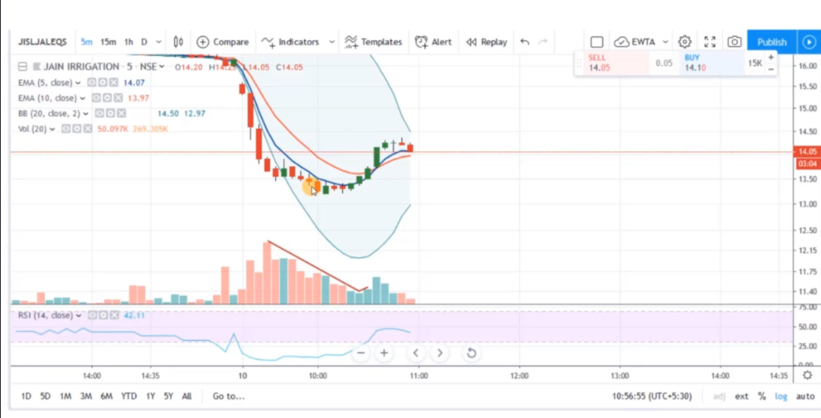

This is JAIN IRRIGATION this stock was also present in the scanner.

You can see this is the opening candle and after a down move

There were very short candles you can see there was a consolidation in the prices.

These are very short candles and volume is also decreasing here.

When I get a high volume volume is greater than the previous bar at this candle.

I entered in my long position because these candles are the green candles and size is also increasing

I placed my stop-loss slightly below my entry point and in just a few minutes there is a profit of

one hundred five dollar.

And now you can see this is a doji candle the next candle is also a doji candle.

So I exited from my long position here because I was trading in opposite direction.

And you can see the next candle was a shooting star candle.

and bollinger band is contracting.

So I was expecting a sideways movement in the stock so in these stocks we can trade in both the direction.

This was a down move

And then there was an up move in the prices you could go short here with our Gap strategy that we will learn

in later action and here when volume was high RSI was giving a positive divergence.

So we can enter here at this candle.

RSI was going in shaded region.

So this was our entry point in the opposite direction of our trade.

The pattern **Bull flag pattern , bear flag pattern, flat top break out and flat bottom break out** all this

strategies we will learn in the course in the later section in this lecture I'm just showing you that

these are the stocks that we should choose for our day trading strategies because in these stocks we can

see high volatile moves in both the direction we can trade not only in the same direction but we can

also trade in opposite direction if we know all the strategies that we will learn in this course.

**Important Indicators To Be Used**

What are the signals that we should get and how to enter and how to exit our position for trading intraday momentum stocks.

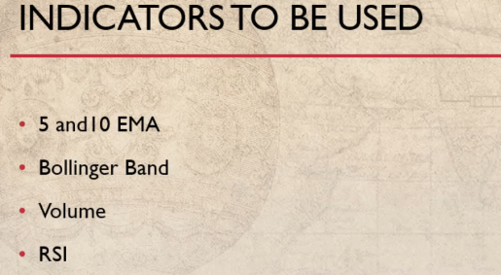

For day trading our moving average every set should be five and 10 EMA and our job chart should be five minute chart.

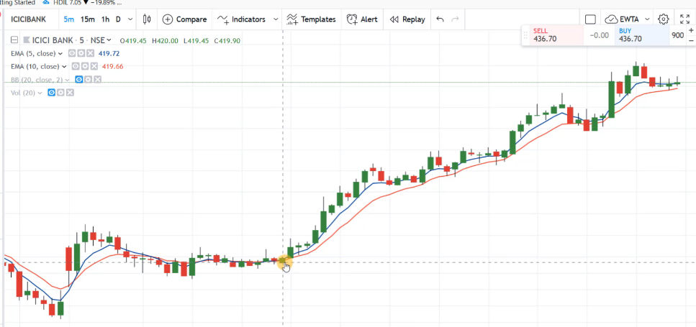

But you should always use exponential moving average set a bullish crossover of five and ten EMA is a buying signal

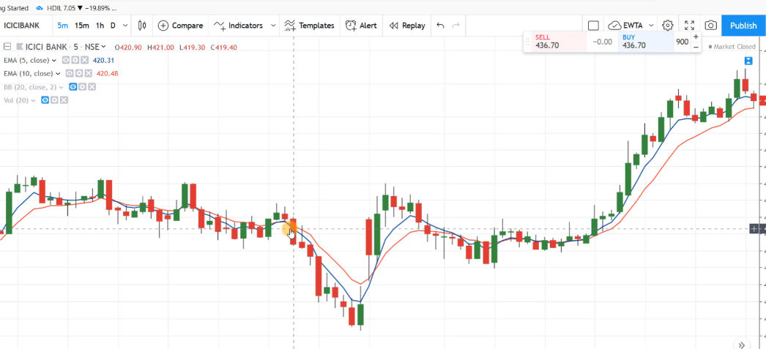

and a bearish crossover of five and ten EMA is a short signal

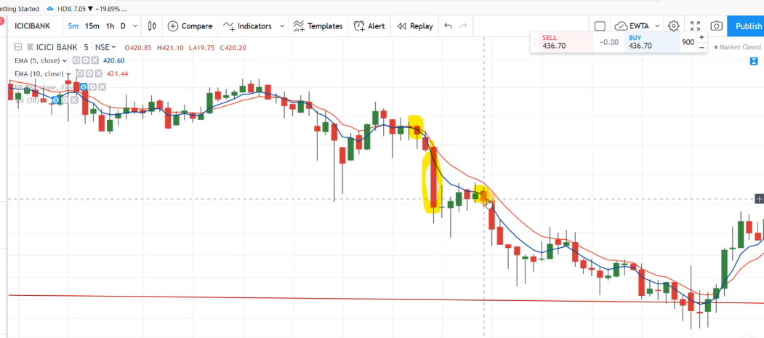

when prices are trading very far from 5 EMA for example you can see this was a bearish crossover of 5 and 10 EMA

And this was the long candle.

So we should not make a short sell position here because this candle is very long.

And prices are trading very far from 5 period moving average.

We should always wait for a pullback and then we can enter into our short sell position in a bearish crossover.

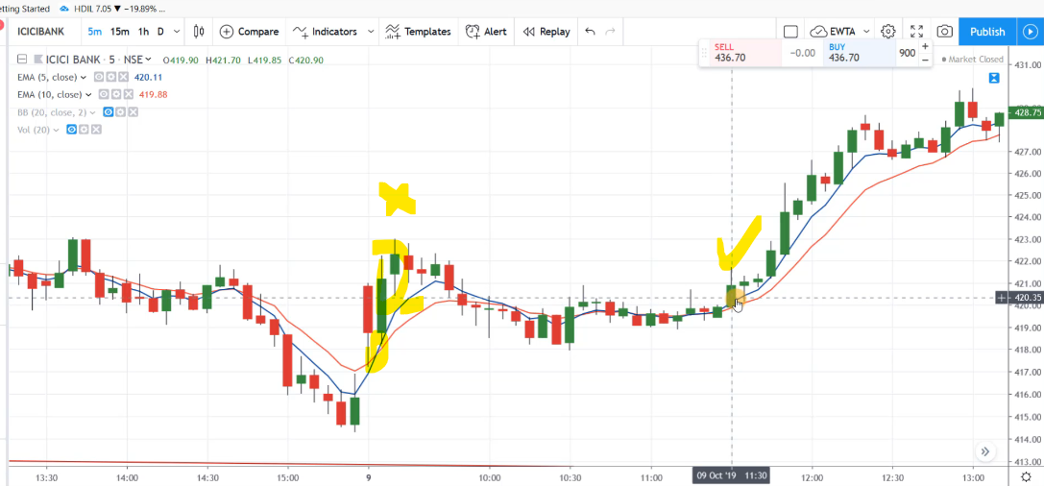

Similarly this was a bullish crossover but we should not enter into a long position when prices are trading very far from five EMA

We should wait for a pullback and when we get a signal again we can enter our trade.

For example you can see this is the bullish crossover and candle is very close to 5 EMA so we can enter

into a long position here but we should not enter here because this is a signal of pullback.

**Bollinger band**

Second indicator is bollinger band For day trading

We need volatility.

So now i trade a stock when bolliinger band is going sideways and its range is very narrow here.

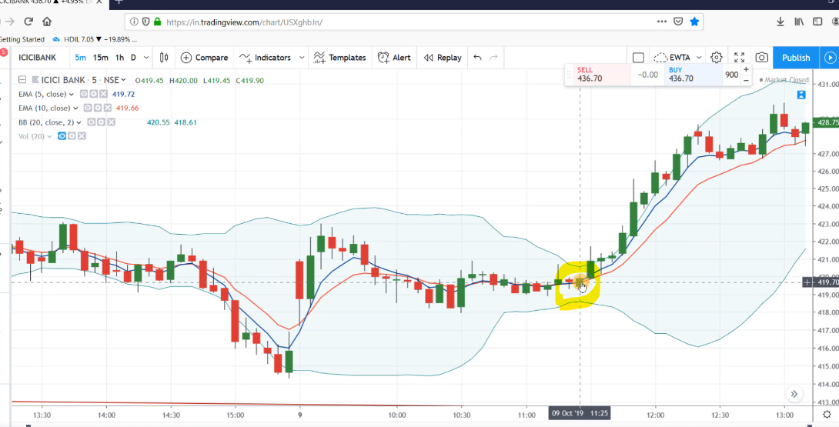

The range of bollinger band is very narrow and it is going sideways.

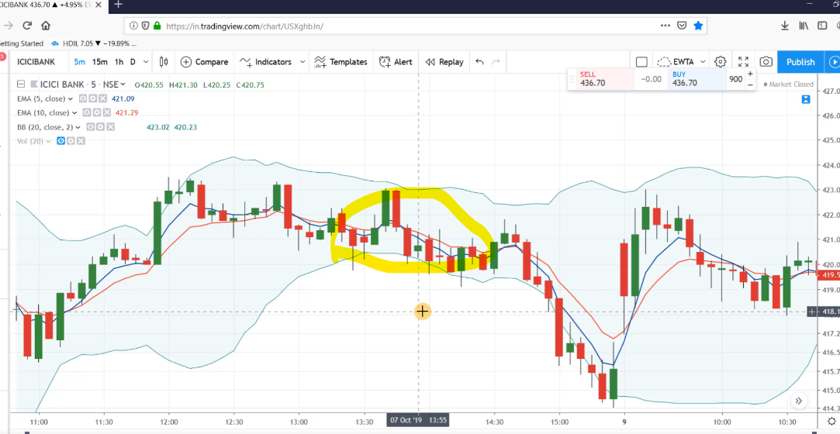

The range of bollinger band is very narrow and it is going sideways.

So in this sideways range we are getting fall signal with the moving average set so when bollinger band expends after a narrow range.

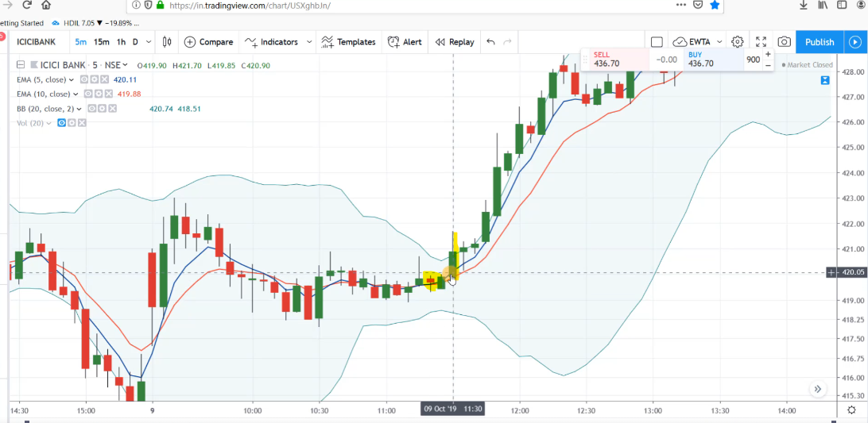

But here at this candle bollinger band is going in upward direction because our prices are touching

the upper band bollinger band is expanding and also moving average set is giving us a buying signal

we can enter our trade here at this candle.

**volume for day trading**

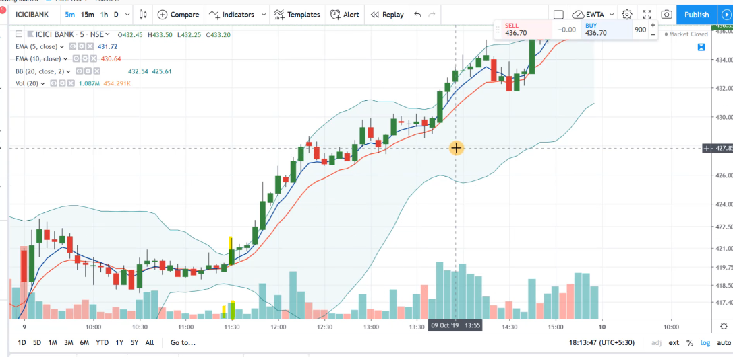

Third indicator is Volume for day trading volume should be higher

than the previous candle .

when we are making an entry in the pullbacks.

We often see low volume that is a signal of continuation of the trend.

So you can see here.

**This was our signal candle with the bollinger band and moving average set**

And at this candle volume is approximately double the previous bar and it is high and at every green

candle volume is high it means there is a momentum in the buying side.

This is a pullback.

3 red candle is showing us a pullback and you can see in these candle volume is low but on green candle

volume is high that shows that that trend is healthy and we can see a momentum move in the trend.

RSI

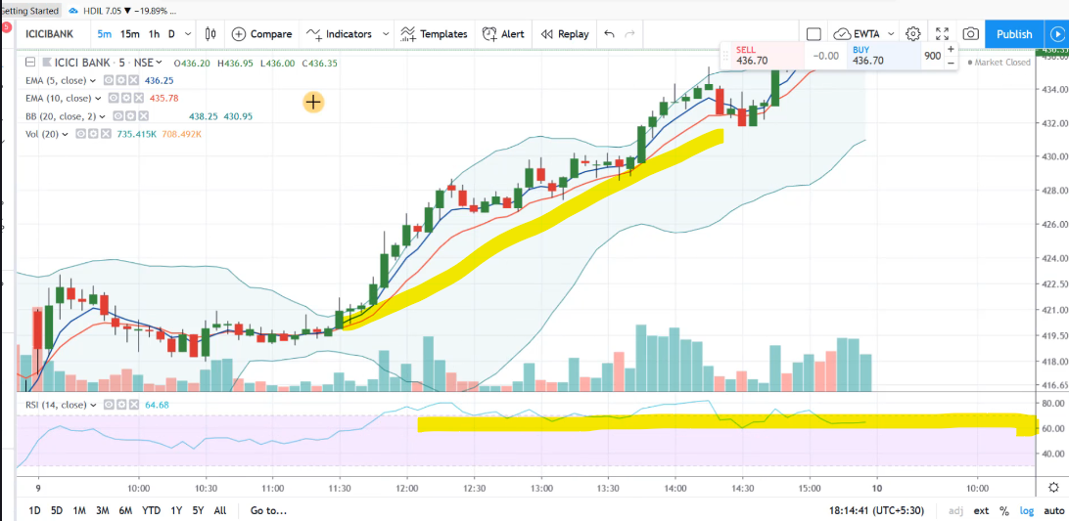

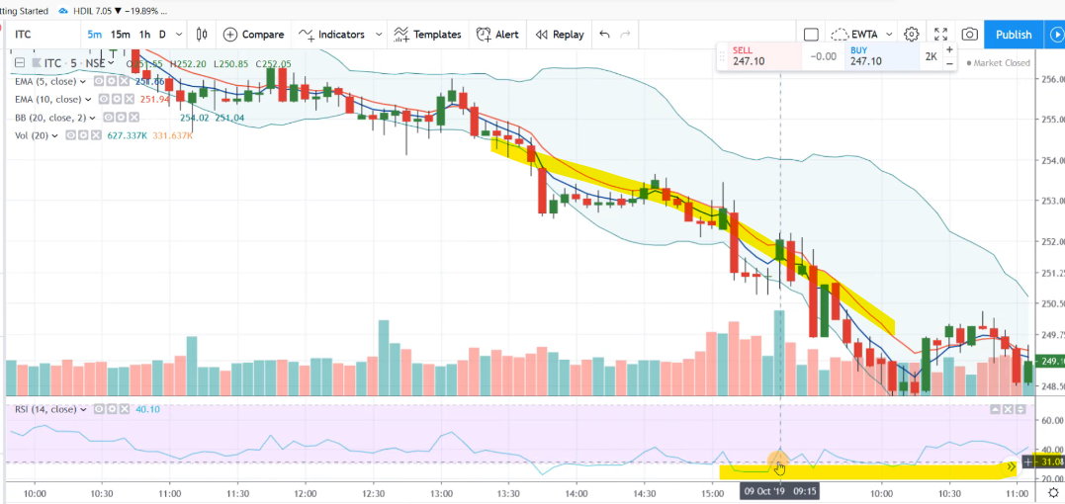 RSI values above 50 show bullishness and below 50 shows bearishness but for momentum stocks we usually

see RSI above 60 and below 30

See this was a momentum move in the stock and during the move RSI is trading above 60 level similarly

for downtrend.

This was our selling signal and during the move RSI is below 30 level.

During this whole move.

So these were our day trading indicators that we should use for our intraday trading how to combine all these

indicators on the chart and how to get trading signals that we will learn in the next lecture.

**How To Get Trading Signals From Indicators**

Now in this lecture we will learn how to trade with these indicators.

our scanned volatile day trading stocks.

So in the morning session near 9:45 am

There were twenty one matches in my screener.

And out of these stocks I traded a few stocks.

we will analyze these trades.

the first stock was IDBI bank see

This was the first opening candle and first opening candle was the **Hammer candle** .

Prices are going in upward direction but still bollinger band is going sideways but you can see this

candle was the long candle and bollinger band was expanding and moving average set was going in upward direction

So after this candle this candle was outside the bollinger band

So I was waiting for the minor correction in the prices.

That is called bull flag pattern.

You can see this is the bull flag pattern and when I got a signal to go in long position volume

was high.

I entered in my long position and in just 15 minutes there was approximately 1:1.5 hour to hour

profit in this stock

